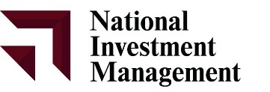
www.nim.mn
Newsletter
April, 2020

HOME ABOUT US OUR SERVICES RESEARCH REGISTER

MONGOLIA ECONOMIC REVIEW 2019
INSIDE THIS ISSUE:
MONGOLIA ECONOMIC REVIEW 2019
- Economy grows by 5.1% in 2019
- Unemployment
- Inflation
- MNT-US$ Exchange Rate
- External Trade
- Banking Sector

MONGOLIA MAJOR EVENTS 2019
- The First Mongolian Company to become a member in London Metal Exchange
- Fitch rates Mongolian Mining Corporation first-time ‘B’
- General Financing Agreement signed with EBRD
- The Brazil-Mongolia Chamber of Commerce launched
- Income from mining sector increases by 24 percent
- Mongolia joins International Forum of Sovereign Wealth Funds as associate member
- China and Mongolia sign major infrastructure deal
- Fourth Mongolian bank to close
- Mongolia has been added to the grey list
Economy grows by 5.1% in 2019
Mongolian economy grew by 5.1% in 2019, compared to the growth rate of 7.2% in the previous year. Mongolia’s economy grew by 6.3% y/y in the first nine months of 2019, down from the 6.6% growth recorded in the same period of last year. Despite the slight slowdown, high growth was maintained on the back of growing minerals output and exports mainly due to continuously rising coal exports to China. The European Bank for Reconstruction and Development (EBRD) projects Mongolia’s economy will slump down to 5.0% in 2020, especially if the economic slowdown in China is intensified by a trade war and geopolitical tensions with the US, as well as the stalling of reforms due to political uncertainty in the run-up to the 2020 parliamentary elections in Mongolia. At the same time, growth is set to be aided by further investment in the underground expansion of Oyu Tolgoi copper and gold mine, while private consumption is also projected as supporting economic growth due to rising real incomes due, in part, to increased salaries for public workers.
Mongolia's Foreign Direct Investment (FDI) increased by 406.8 USD mln in December 2019, compared with an increase of 161.3 USD mn in the previous month. Mongolia’s economic growth remains heavily dependent on investment, which is largely funded by volatile FDI flows. The IMF’s Extended Fund Facility program improved national credibility among foreign investors and gradually attracted FDI. Mongolia’s Foreign Portfolio Investment fell by 23.6 USD million in December 2019.

Unemployment
The unemployment rate of Mongolia reached 9.90 % in December 2019 with 126 thousand unemployed people. In 2018, the employment expansion in the industrial, mining manufacturing and construction services were the largest contributors to employment growth. However, despite an increasing share of employment in the industrial sector, the majority of the employed population remains engaged in low-end services and agriculture. Although the labor market conditions have improved, the gender wage gap remains wide and the female labor force participation rate is at a historic low. The gap is partly explained by the fact that many women are employed in informal or low-end service activities, while and increasing number of men have obtained jobs in better-paid sectors (such as mining, manufacturing and construction). To reduce gender disparities in Mongolia’s labor market, a recent qualitative study suggested a package of policy reforms including promoting a mandatory gender nondiscrimination policy in hiring, ensuring access to finance and training for female-operated micro-businesses, and expanding the quantity and quality of early childcare services. Monthly Earnings of Mongolia stood at 439.04 USD and the country's Labour Force Participation Rate dropped to 60.10 % in 2019.

Inflation
The annual inflation rate in Mongolia went down to 5.2% as of December 2019, went down by 2.9% from previous year. It was the lowest inflation rate since July, as cost slowed for food & non-alcoholic beverages (14 percent vs 15.6 percent in September); clothing & footwear (8.1 percent vs 8.9 percent); housing & utilities (8.6 percent vs 11.3 percent); furniture & household equipment (4.4 percent vs 4.6 percent); recreation & culture (10.8 percent vs 13 percent); alcoholic beverages & tobacco (3.2 percent vs 3.6 percent); miscellaneous goods & services (5.7 percent vs 6.0 percent); health (4.8 percent vs 5.3 percent) and restaurants & hotels (11.9 percent vs 12.3 percent). In addition, transport cost dropped 0.8 percent, after increasing 2.1 percent. On a monthly basis, consumer prices fell 0.3 percent, after a flat reading in September.

www.nim.mn
pg. 2
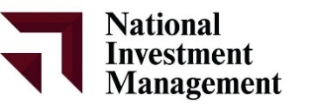

MNT-US$ Exchange Rate
The exchange rate for the year 2019, has been increasing gradually since April. Mongolia's Exchange Rate against USD averaged 2,715.22 (MNT/USD) in December 2019, compared with 2,701.11 MNT/USD in the previous month. Pressure on the exchange rate was moderate during the first half of the year but accelerated thereafter, partly reflecting general U.S. dollar strength against the currencies of Mongolia’s peers and neighbors and partly explained by some market panic prompted by the gray listing of Mongolia by the Financial Action Task Force (FATF).
External Trade
In 2019, Mongolia traded with 152 countries from all over the world and total trade turnover reached USD 13.7 billion, of which USD 7.6 billion were exports and USD 6.1 billion were imports. Total foreign trade turnover increased by USD 860.6 (6.7%) million, of which exports increased by USD 608.0 million (8.7%) and imports increased by USD 252.6 million (8.0%) compared to the same period of previous year. Mongolian foreign trade balance has been in surplus since 2014 and foreign trade surplus reached USD 1.5 billion in 2019, increased by USD 355.4 million (31.3%) from previous year. In December 2019, foreign trade surplus reached to USD 20.5 million. Compared to the previous month, foreign trade surplus increased by USD 12.9 million. In total turnover, trades with two neighbor countries China and Russia have highest shares where trade with China was USD 8.9 billion in 2019, which is 64.4% of total goods turnover and 89.1 percent of exports.

www.nim.mn
pg. 3

In December 2019, exports and imports reached to USD 564.2 million and USD 543.6 million, respectively. Compared to the previous month, exports increased by USD 37.3 million and imports increased by USD 24.4 million. The 608.0 million increase in exports from the same period of previous year was mainly due to the increases in exports of USD 288.2 million in bituminous coal and USD 273.9 million in raw or semi-manufactured gold. The USD 252.6 million increase in imports from the same period of previous year was mainly due to USD 46.5 million increase in mineral products imports, especially, USD 92.6 million increase in diesel imports and USD 267.0 million increase in imports of transport vehicles and its spare parts. Exports of mineral products, textiles and textile articles, natural or cultured stones, precious metals jewelry made up 94.9 percent of total export. On the other hand, 68.9 percent of imports was mineral products, machinery, equipment, electric appliances, transport vehicle and its spare parts and food products.

Banking Sector:
Total loans outstanding at Mongolia’s commercial banks reached MNT 17.9 trillion as of December 2019. Total assets in the banking sector reached 97 percent of GDP in 2019 compared to 56 percent in 2008. Mongolia’s financial sector is highly dominated by the banking system (close to 90 percent as of H1 2019), 27 and consequently, loans from commercial banks are the main financing source for both individuals and businesses. Total outstanding loans in the banking sector are equivalent to 56.3 percent of GDP in 2019. Meanwhile, total deposits and current accounts (individuals and companies) represent 51 percent of GDP.

www.nim.mn
pg. 4

The loan portfolio remains concentrated in five sectors that have strong links with the mining sector. Loan portfolios in these economic sectors account for about half of total loans, while household loans including mortgage, consumption, and salary loans constitute the remaining half. A tightening of monetary and credit policies brought the most recent credit boom to a halt in 2019.
NPLs are concentrated in the corporate sector, reflecting weak lending standards during previous credit expansions and suggesting underlying financial sector vulnerabilities. The NPL ratio of the corporate sector reached 19 percent, its highest level, during the 2008–09 global financial crisis. But in December 2019, the NPL ratio of the corporate sector approached 18 percent again. Corporate sector NPLs are mainly concentrated in a few risky sectors such as mining, manufacturing, construction, and trade, which are highly vulnerable to a volatile mining sector. Loan loss provisioning (LLP) remains low for many key sectors. The mining, construction, trade, and real estate sectors account for over 80 percent of total NPLs, but LLP of these sectors ranged between 71 and 76 percent as of December 2019. However, manufacturing sector LLP stood at 83 percent. Meanwhile, pension loans have exhibited LLP equaling or exceeding 100 percent.
Corporate credit has increased sharply since mid-2018 amid an economic recovery and the BoM’s efforts to contain individual loans. Corporate credit growth to the trade and mining sectors accelerated (16.2 and 20.2 percent, respectively) in 2019. Although accounting for a total of 44 percent of GDP in 2018, the mining, agriculture, and manufacturing sectors held about 35 percent of total corporate credit in 2019. The trade (wholesale/retail) and construction sectors held 43 percent of total credit while accounting for only 13 percent of GDP. Another characteristic of credit in Mongolia is its concentration in a limited number of firms. The majority of total credit in the banking system went to only a few large companies. Only 13 percent of total corporate borrowers acquired more than 80 percent of the total outstanding corporate loans. Basically, corporate loans are heavily concentrated in a few large companies, which indicates serious risk of exposure to a limited number of borrowers. Moreover, a significant majority of individual borrowers have taken more than half of the total individual loans. Over 90 percent of the total household borrowers have acquired credit up to MNT 20 million (about US$7,500), representing about 60 percent of the total outstanding individual loans. In contrast, only 10 percent of the individual borrowers own about 40 percent of the loans. Also, only a minority of individuals own more than half of bank individual deposits, pointing to banks’ dependence on a few large depositors. In fact, on average, only 1 percent of household depositors holds deposits exceeding MNT 20 million (US$7,500).

www.nim.mn
pg. 5

MONGOLIA MAJOR EVENTS 2019:
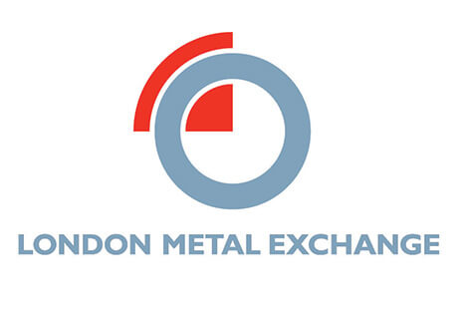
The First Mongolian Company to become a member in London Metal Exchange
Achit Ikht LLC of Mongolia has become a member of the London Metal Exchange (LME). Particularly, on February 6, LME announced on its official website that the company had been approved for membership of LME pursuant to its notice 19/024 of January 23. Achit Ikht LLC operates Mongolia’s first modern hydrometallurgical plant, producing copper cathode and last year, the company issued preference shares to its own and Erdenet Mining Corporation’s employees.

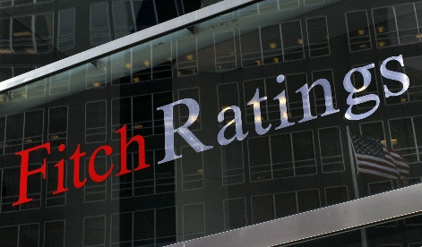
Fitch rates Mongolian Mining Corporation first-time ‘B’
Fitch Ratings has assigned Mongolia-based coal producer Mongolian Mining Corporation (MMC) a Long-Term Foreign-Currency Issuer Default Rating (IDR) of 'B'. The Outlook is Stable. Fitch has also assigned a 'B (EXP)' expected rating with expected Recovery Rating of 'RR4' to MMC's proposed US dollar-denominated senior notes. MMC's rating is constrained by its small scale, single-product focus and limited cost competitiveness outside of northern China. However, MMC has flexibility in capex, which should give it sufficient buffer to continue generating free cash flows during a coal price downturn. The proposed notes will be co-issued by MMC and its wholly owned-subsidiary, Energy Resources LLC, and guaranteed by most of its operating subsidiaries. The notes will constitute senior unsecured obligations of MMC as they represent the company's unconditional and irrevocable obligations. MMC intends to use the net proceeds from the proposed note issuance to refinance its existing secured notes and part of its perpetual notes. Concurrently, the company expects to fully repay the senior secured loan with cash generated from its Baruun Naran mine operations. The final rating on the proposed notes is subject to the receipt of final documentation conforming to the information already received.

General Financing Agreement signed with EBRD
General Financing Agreement between the Government of Mongolia and the European Bank for Reconstruction and Development (EBRD) was signed by Minister of Finance Ch.Khurelbaatar and Head of Mongolia Unit at the EBRD Irina Kravchenko. By signing the agreement, the EBRD will grant USD 300 million credit financing to the Mongolian Government for the implementation of projects and programs in road and infrastructure sectors. The sides agreed to finance the project on construction of additional two-lane road in route Ulaanbaatar-Darkhan at the first stage.

www.nim.mn
pg. 6

The Brazil-Mongolia Chamber of Commerce launched
The Brazil-Mongolia Chamber of Commerce (BMCC) was officially registered on June 27 to start operating in the country. With a team of six members plus advisors, the BMCC’s mission is to promote trade and investment activities between Brazil and Mongolia, and to assist on the development of closer ties connecting the two nations’ business communities. The opportunity the CEO refers to is of creating an organization that could represent and link both countries, given the great increase their networking has achieved in Mongolia making it possible to strengthen the plans of the Chamber to be created, through the support of entrepreneurs and Government agents from both nationalities. When it comes to the contributions the BMCC can bring, Uchoa believes it will boost the trade potential of Brazil and Mongolia, including in the areas of mining and farming where both countries have great potential. He added that “this can result in several business possibilities of technology exchange and good practices. Furthermore, our Chamber also represents the first step towards creating a future local organization to incentive trade relations with other Latin American countries.”
Income from mining sector increases by 24 percent
The Ministry of Mining and Heavy Industry accumulated MNT 1.7 trillion billion to the state budget as taxes, fees and royalties. MNT 22.2 billion has come from gold mining, MNT 788.7 billion--from coal, MNT 53.6 billion -- zinc, MNT 723.1 billion --copper, MNT 14.5 billion --iron, MNT 19 billion --fluorspar and MNT 41 billion from others. Against the same period of the previous year, the income from major commodities increased by MNT 321.3 billion or 24 percent; incomes from coal extraction increased by MNT 230.4 billion (41.3 percent), copper--by MNT 97.9 billion (15.7 percent), iron—by MNT 5.1 billion (53.8 percent) and fluorspar --by MNT 9.3 billion (96.9 percent). In Mongolia, a total of 8.15 million barrel or 1.1 million tons of oil is planned to be extracted and exported, with accumulation of MNT335.6 billion to the State Budget. Also, there are registered 2889 exploration and mining licenses of mineral resources throughout the country.
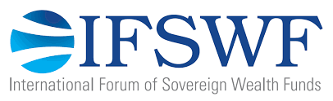
Mongolia joins International Forum of Sovereign Wealth Funds as associate member
On September 12, the 11th annual meeting of the International Forum of Sovereign Wealth Funds (IFSWF) was hosted in Juneau, Alaska by Alaska Permanent Fund Corporation (APFC). The IFSWF annual meeting brings together members and financial leaders to discuss the key global issues affecting investors. Since its last meeting held in Marrakech, Morocco, the IFSWF has welcomed two new full members – Fonds Souverain d'Investissements Stratégiques (FONSIS) of Senegal and Bpifrance – and four new associate members – the Egypt Fund, the Future Heritage Fund of Mongolia, the National Infrastructure Investment Fund of India and the National Investment Fund of Cyprus. The Future Heritage Fund of Mongolia was established in 2015 with the intent of collecting a portion of mineral revenue for future generations’ use and the main sources of the FHF's financing include 65 percent of the royalty payments and the dividends to the state owned shares of legal entities with state ownership participation or state owned enterprises which possess mining licenses for mineral deposits. The IFSWF is a global network of sovereign wealth funds (SWFs) established in 2009 to enhance collaboration and dialogue between members, to promote a deeper understanding of SWF activity and to raise the standard for SWF best practice and governance.

www.nim.mn
pg. 7

China and Mongolia sign major infrastructure deal
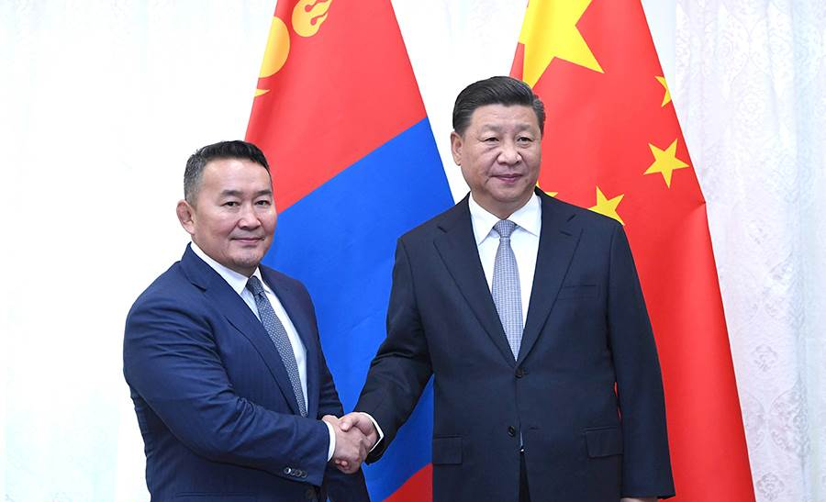
China and Mongolia have signed a cooperation plan on promoting the alignment of the China-proposed Belt and Road Initiative (BRI) with Mongolia’s Development Road Programme. Xi called for more efforts to align the BRI with the Development Road Programme and promote the building of the China-Mongolia-Russia economic corridor. Proposed by Xi in 2013, the BRI comprises the Silk Road Economic Belt and the 21st Century Maritime Silk Road, and aims to build trade and infrastructure networks connecting Asia with Europe and Africa along and beyond the ancient Silk Road routes. Under the BRI, China, Mongolia and Russia signed an agreement in 2016 to build an economic corridor linking the three neighbours and boost transportation connectivity and economic cooperation in border regions. The Chinese and Mongolian governments signed a memorandum of understanding on BRI cooperation during the first BRF in May 2017.

Fourth Mongolian bank to close
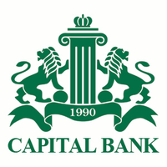
Capital Bank LLC, one of the 14 commercial banks in Mongolia has gone into liquidation by decree of the Central Bank of Mongolia. According to N.Batsaikhan, who is chief examiner at Mongol Bank, the volume of Capital Bank’s low grade credit reached MNT 208 billion – equivalent to 80 percent of its total credits.
Capital Bank LLC, has 256 thousand savings accounts by individuals and enterprises; 95 percent of accounts were insured, said, Kh.Bum-Erdene, director of Savings and Insurance Corporation.
Capital Banks LLC was founded in 1990 and has changed its name twice in 1998 and 2013. It is the fourth financial institution to have closed down in the last decade, following Zoos (Coin) Bank in 2009, Anod Bank in 2010 and the Savings Bank in 2013.
Regarding its place in the Mongolian banking system. Capital Bank LLC accounts for 1.1 percent.

www.nim.mn
pg. 8

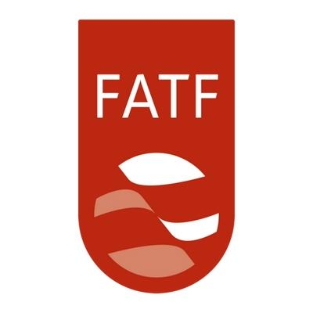
Mongolia has been added to the grey list
Having failed to adequately comply with the recommendations of the Financial Action Task Force (FATF), concerning anti-money laundering and counter-terrorism financing measures, Mongolia has been added to the FATF’s grey list along with Iraq, Zimbabwe and N.Korea.
Specialists at the Paris-based watchdog consider Mongolia is risking all foreign transactions and investments, slowing down the economy and leading to further uncertainty. In Ulaanbaatar, there is consternation at the decision. Mongolia succeeded in getting out of the grey list in 2014 after taking actions money laundering. Mongolia has worked to address weaknesses in its technical compliance with the FATF’s standards since 2017. Meanwhile, its economy is in recovery following a bailout from the International Monetary Fund in 2017.
Since the completion of its mutual evaluation report (MER) in 2017, Mongolia has made progress on a number of its MER recommended actions to improve technical compliance and effectiveness. Mongolia completed 35 out of 40 technical compliances and seven out of 11 indicates.
The FATF is an inter-governmental body established in 1989 to combat money laundering, terrorist financing and other related threats to the integrity of the international financial system.
The Mongolian Central Bank or Mongol Bank is aiming to exit from FATF grey list in 2020.

Sources:
Bank of Mongolia
Worldbank
International Monetary Fund (IMF)
National Statistical Office of Mongolia (NSO)
Mongolian Stock Exchange (MSE)
Financial Regulatory Commission of Mongolia (FRC)
Montsame News
Bloomberg

www.nim.mn
pg. 9

